Model
- Deaths in jan-dec, #events X years before etc.
Deaths_(year+lag) ~ (#events_year) + …
and (average#events_year)
- Sensitivity of above but with event bin of last X years

Mortality data

Death counts/rates
By county
1980-2017 available (could go further back maybe but without covariate)
Annual coded
By 10-year age group
Male/Female
[[[Map of cases for cardiovascular/respiratory/injuries]]]

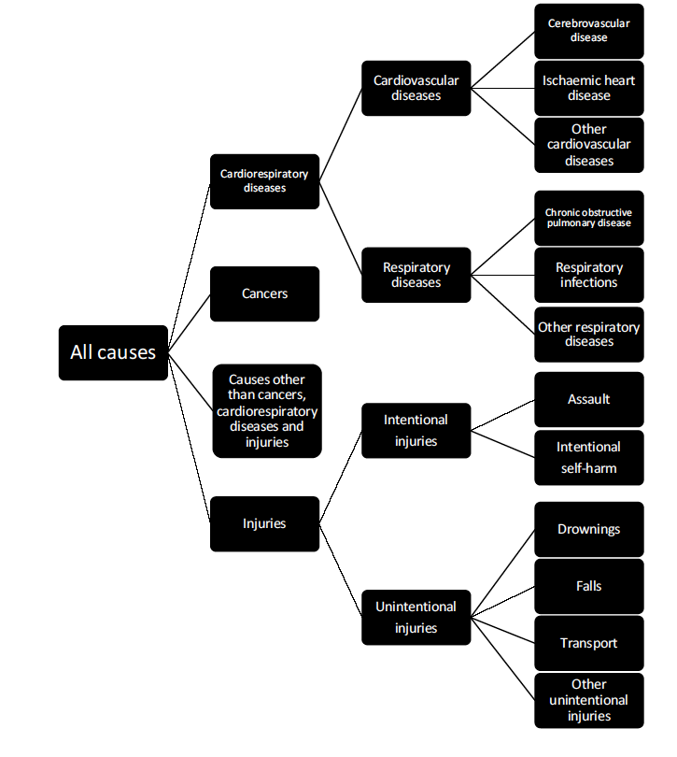

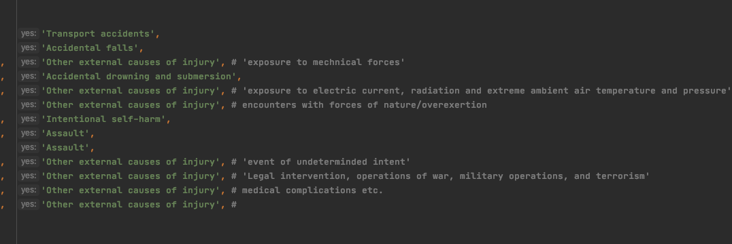

Exposure data

1999-2016
Daily
Exposure on/off
By county

Average/total count of events of past XX years?

Annual covariate

• Per capita income ($), adjusted for inflation using the year 2000 as a baseline, from the CA1 data set from the Bureau of Economic Analysis (https://apps.bea.gov/regional/downloadzip.cfm) (used as log-transformed).
• Percentage of population whose family income is below the poverty threshold, from the US Census Bureau’s Small-Area Income and Poverty Estimates data set (https://www.census.gov/programs-surveys/saipe/data/datasets.All.html).
• Percentage of population who are of Black or African American race, through the NCHS bridged-race data set (https://www.cdc.gov/nchs/nvss/bridged_race.htm).
• Education, measured as percentage of population above the age of 25 years who have a high-school diploma or above, from the US Department of Agriculture (https://www.ers.usda.gov/data-products/county-level-data-sets/download-data/). The data set contained US Decennial Census data for 1970, 1980, 1990, and 2000 and American Community Survey 5-year estimates for the period 2011 to 2015. We linearly interpolated between 1990 and 2000 data to estimate the percentage of the population who had graduated from high school for 1999. We similarly estimated values for each county for years from 2001 to 2010 by linearly interpolating between 2000 and 2011 data.
• Unemployment, measured as percentage of population who are unemployed, calculated by dividing the number of people who are unemployed—available from the Bureau of Labor Statistics (https://www.bls.gov/lau/)—by total county population.
• Urbanicity, measured as percentage of population who live in urban areas, from the US Census Bureau’s decennial census data for 2000 and 2010 (https://factfinder.census.gov/faces/nav/jsf/pages/index.xhtml). We linearly interpolated between 2000 and 2010 data to estimate the percentage of population living in urban areas for 2001 to 2009. We used data from the year 2000 for 1999, and those from 2010 for 2011 to 2015.
• Hurricane season temperature average?

